
3rd Floor, wing A and B, KUNAL PLAZA, Office number 39, off Mumbai Pune Highway, Pimpri-Chinchwad, Maharashtra 411019
A
PROJECT REPORT ON
“Design and Implementation of a Network in Cisco Packet Tracer for Small Home Office”

FOR
SEVENMENTOR PVT LTD

IN PARTIAL FULFILLMENT OF THE REQUIREMENTS FOR THE PROGRAM OF AWS SOLUTIONS AR.ASSOCIATE

SUBMITTED BY
Gandhar Bodas
(2024-2025)

SUBMITTED TO
SEVENMENTOR PVT LTD

UNDER THE GUIDANCE OF
Trainer. Nisha Mandot

SEVENMENTOR PVT LDT
3rd Floor, wing A and B, KUNAL PLAZA, Office number 39, off Mumbai Pune Highway, Pimpri-Chinchwad, Maharashtra 411019
CERTIFICATE
This is to certify that, Project entitled “Design and Implementation of a Network in Cisco Packet Tracer for Accounts and Delivery Departments” has been carried out by the following student in partial
fulfilment of CCNA 200-301 program for the academic
Year 2024-25 as per the guidelines of the SevenMentor Pvt.Ltd, Pune.

Student Name: Gandhar Bodas

Date:
Place: Pune

Gandhar Bodas Yallapa Patil Nisha Mandot
(Tech Trainer) (TL- Networking Dept.) (Director)

ACKNOWLEDGMENT
“Task successful” makes everyone happy. But the happiness will be gold without glitter if we didn’t state the persons who have supported us to make it a success.
Success will be crowned to people who made it a reality but the people whose constant guidance and encouragement made it possible will be crowned first on the eve of success.
This acknowledgement transcends the reality of formality when we would like to express deep gratitude and respect to all those people behind the screen who guided, inspired and helped me for the completion of our project work.
I considered myself lucky enough to get such a good project. This project would add as an asset to my academic profile.
I would like to express special thanks to Trainer. Nisha Mandot and Networking Head Yallapa Patil for their constant motivation and valuable help through the project work and I express my gratitude to Nisha Mandot, Directory of SevenMentor, and Pune for giving me an opportunity to carry out the project work,

Finally I would like to thanks my friends for their co-operation to complete this project.

Gandhar Bodas

Project Synopsis:
XYZ company is a fastest growing company in eastern Australia with more than 200 billion customers globally the company deals with ceiling and buying of food items which are basically operated from the headquarters. The company is standing to open a branch near the local village bonalbo . Thus , the company requires young it graduates to designed the network for the branch the network is intended to operates separately from the headquarter.
Being a small network the company has the following requirements during implementation.
a ) One router and one switch to be used all Cisco bracket products
b ) Three departments admin finance and customer service
c ) Is department is required to be in different villains
d ) Is department is required to have wireless network for the users
e ) Host devices in the network are required to be obtained ipv4 address automatically
f ) Devices in All the departments I required to communicate with each other
Assume the ISP gave out of base network of 192.168.1.0 us network engineer who has been hired design and implement and network considering the above requirement.
Topology:
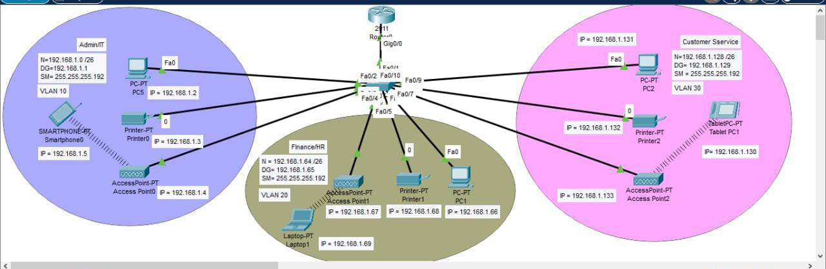

Project Description:
- Network Setup:
  - Admin Department : PC, Printer Access poin connected through wireless smartphone all are connected via a switch.
  - Finance Department : PC, Printer Access poin connected through wireless smartphone all are connected via a switch.
  - Customer Service Department : PC, Printer Access poin connected through wireless smartphone all are.

- IP Addressing Scheme :
  - Network Address: 192.168.1.0/24
  - Admin Department: 192.168.40.2 – 192.168.40.10
  - Delivery Department: 192.168.40.11 – 192.168.40.20
  - Router Interfaces: Assigned with valid IPs from the same subnet.
- Configuration Tasks:
  - Assign static IP addresses to all PCs.
  - Configure router interfaces with the corresponding IP addresses.
  - Set up default gateways on PCs pointing to the router’s interface.
  - Connect all devices using appropriate cables (copper straight-through/cross-over as needed).
  - Verify connectivity using the ping command.
- Testing & Verification:
  - PCs in Delivery Department should successfully ping PCs in Accounts Department.
  - Cross-department communication confirms proper network setup and routing.
Configuration:

IP addressing plan (recommended)
- Overall network: 192.168.40.0/24 splitted into two /26 networks:
  - Accounts: 192.168.40.0/26 → mask 255.255.255.192
    - Router (gateway): 192.168.40.1
    - PC-Acc1: 192.168.40.2
    - PC-Acc2: 192.168.40.3
  - Delivery: 192.168.40.64/26 → mask 255.255.255.192
    - Router (gateway): 192.168.40.65
    - PC-Del1: 192.168.40.66
    - PC-Del2: 192.168.40.67

Physical connections & cable types
- PCs → respective Switch: Copper Straight-through (PC Fa0 → Switch Fa0/1 etc.)
- Switch-Acc Fa0/24 → Router1 Gi0/0 (or Fa0/0): Copper Straight-through
- Switch-Del Fa0/24 → Router1 Gi0/1 (or Fa0/1): Copper Straight-through
Use the router interface names that exist on your Packet Tracer router (GigabitEthernet0/0, FastEthernet0/0, etc.). Replace Gi0/0 in commands if your router uses Fa0/0.

Step 1 — Build the topology in Packet Tracer
- Place devices: 1 Router, 2 Switches, 4 PCs.
- Connect devices using cable types above and correct ports.

Step 2 — Configure Router (CLI)
Open router CLI and enter configuration mode. Example uses GigabitEthernet0/0 & GigabitEthernet0/1. If your router only has FastEthernet, use those names.
Router> enable
Router# configure terminal
Router(config)# hostname Router1

! Configure Accounts interface
Router1(config)# interface GigabitEthernet0/0
Router1(config-if)# ip address 192.168.40.1 255.255.255.192
Router1(config-if)# no shutdown
Router1(config-if)# exit

! Configure Delivery interface
Router1(config)# interface GigabitEthernet0/1
Router1(config-if)# ip address 192.168.40.65 255.255.255.192
Router1(config-if)# no shutdown
Router1(config-if)# exit

Router1(config)# end
Router1# write memory

Step 3 — (Optional) Basic Switch settings
Switch> enable
Switch# configure terminal
Switch(config)# hostname Switch-Acc
Switch-Acc(config)# interface vlan 1
Switch-Acc(config-if)# ip address 192.168.40.10 255.255.255.192 ! example mgmt IP in Accounts
Switch-Acc(config-if)# no shutdown
Switch-Acc(config)# exit
Switch-Acc(config)# ip default-gateway 192.168.40.1
Switch-Acc(config)# end
Switch-Acc# write memory
Step 4 — Configure PCs (GUI on each PC)
On each PC: Desktop → IP Configuration → set static values:
- PC-Acc1
  - IP Address: 192.168.40.2
  - Subnet Mask: 255.255.255.192
  - Default Gateway: 192.168.40.1
- PC-Acc2
  - IP Address: 192.168.40.3
  - Subnet Mask: 255.255.255.192
  - Default Gateway: 192.168.40.1
- PC-Del1
  - IP Address: 192.168.40.66
  - Subnet Mask: 255.255.255.192
  - Default Gateway: 192.168.40.65
- PC-Del2
  - IP Address: 192.168.40.67
  - Subnet Mask: 255.255.255.192
  - Default Gateway: 192.168.40.65
Step 5 — Verify interfaces and routing on Router
Router1# show ip interface brief
Router1# show running-config | section interface
Router1# show ip route
You should see two connected routes:
- 192.168.40.0/26 via Gi0/0
- 192.168.40.64/26 via Gi0/1
Step 6 — Test connectivity
From each PC use the Packet Tracer command prompt:
- Ping the local gateway:
  - From PC-Acc1: ping 192.168.40.1 → should reply.
  - From PC-Del1: ping 192.168.40.65 → should reply.
- Ping cross-department PC:
  - From PC-Del1 run ping 192.168.40.2 (PC-Acc1) → should succeed.
  - From PC-Acc2 run ping 192.168.40.66 (PC-Del1) → should succeed.
Successful pings confirm router is forwarding between subnets.

Step 7 — Save configs
- On Router: write memory or copy running-config startup-config
- On Switches (if you changed): write memory
END

